DAILY ASSESSMENT FORMAT

|  |  |  |  |
| --- | --- | --- | --- |
| Date: | 29/07/2020 | Name: | Persis P |
| Course: | Coursera | USN: | 4AL17EC069 |
| Topic: | • Basic Statics | Semester & Section: | 6 & B |
| Github  Repository: |  |  |  |

SESSION DETAILS

Session images

Report:

Statistical conclusion validity

is the degree to which conclusions about the relationship

among

variables

based on the data are correct or "reasonable". This began a

s being solely about

whether the statistical conclusion about the relationship of the variables was correct, but now

there is a movement towards moving to "reasonable" conclusions that use: quantitative,

statistical, and qualitative data

.

Fundamentally, tw

o types of errors can occur:

type I

(

finding a

difference or correlation when none exists) and

type II

(

finding no difference or correlation when

one exists). Statistical conclusion validity concerns the qualities of the study that make these types

of errors more likely. Statistical conclusion validity in

volves ensuring the use of adequate sampling

procedures, appropriate statistical tests, and reliable measurement procedures.

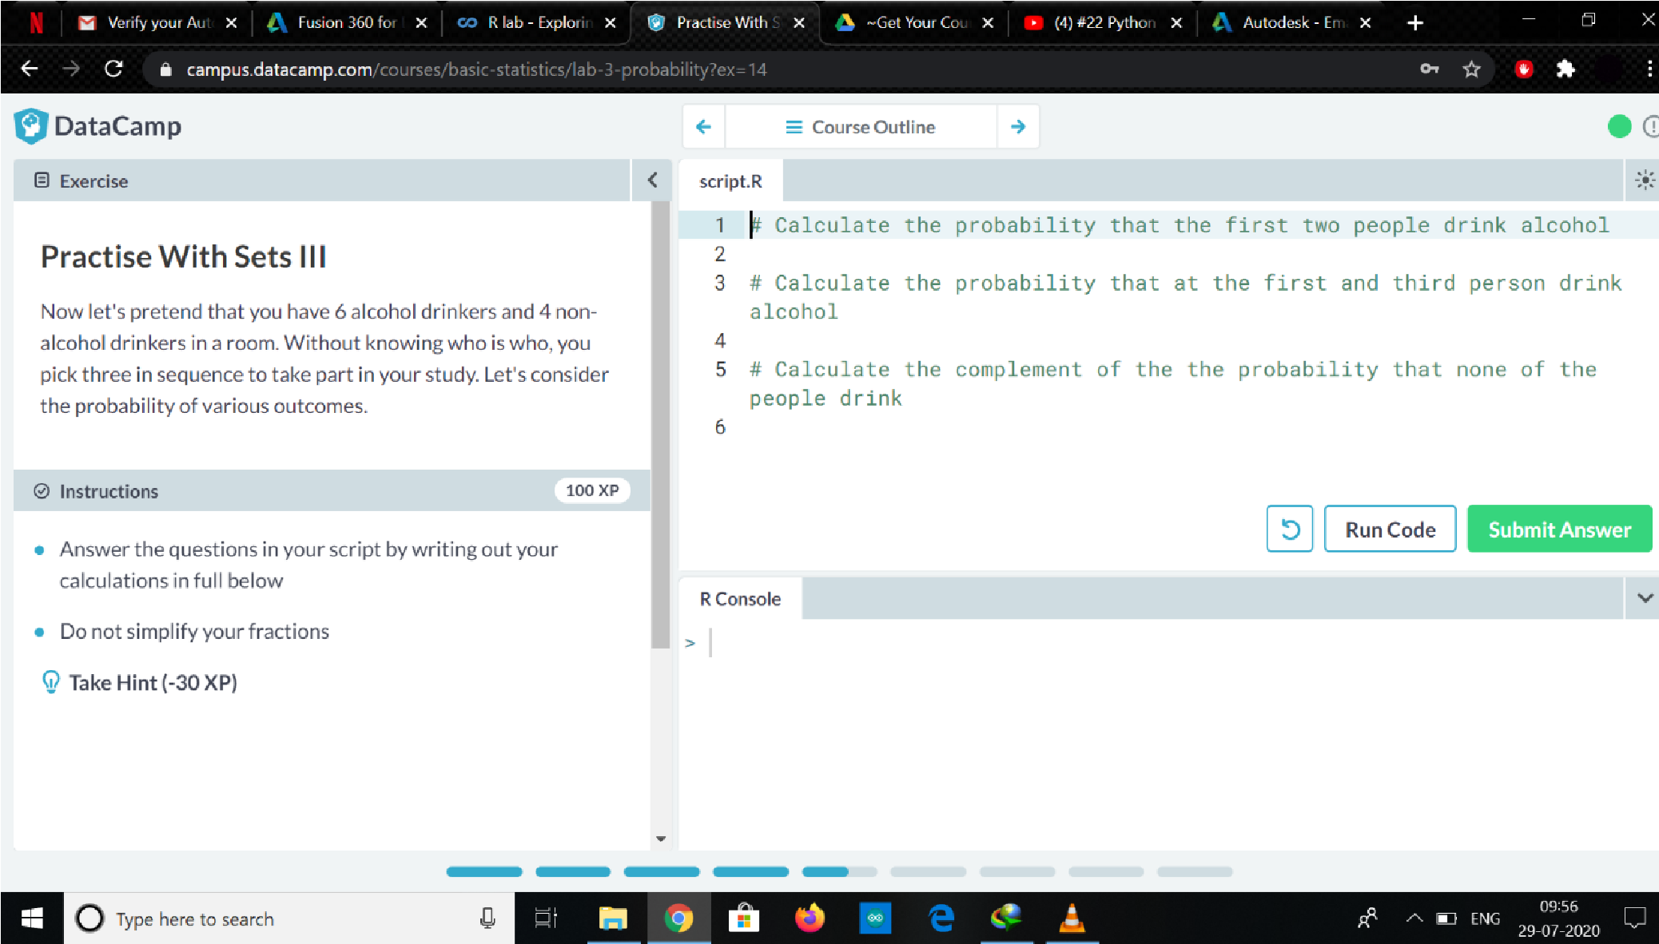

|  |
| --- |
| Low statistical power:  Power is the probability of correctly rejecting the null hypothesis when it is false (inverse of the type II error rate). Experiments with low power have a higher probability of incorrectly accepting the null hypothesis—that is, committing a type II error and concluding that there is no effect when there actually is (I.e. there is real covariation between the cause and effect). Low power occurs when the sample size of the study is too small given other factors (small effect sizes, large group variability, unreliable measures, etc.).  Violated assumptions of the test statistics:  Most statistical tests (particularly inferential statistics) involve assumptions about the data that make the analysis suitable for testing a hypothesis. Violating the assumptions of statistical tests can lead to incorrect inferences about the cause-effect relationship. The robustness of a test indicates how sensitive it is to violations. Violations of assumptions may make tests more or less likely to make type I or II errors.  Dredging and the error rate problem:  Each hypothesis test involves a set risk of a type I error (the alpha rate). If a researcher searches or "dredges" through their data, testing many different hypotheses to find a significant effect, they are inflating their type I error rate. The more the researcher repeatedly tests the data, the higher the chance of observing a type I error and making an incorrect inference about the existence of a relationship.  Unreliability of measures:  If the dependent and/or independent variable(s) are not measured reliably (i.e. with large amounts of measurement error), incorrect conclusions can be drawn. Restriction of range:  Restriction of range, such as floor and ceiling effects or selection effects, reduce the power of the experiment, and increase the chance of a type II error.[5] This is because correlations are attenuated (weakened) by reduced variability (see, for example, the equation for the Pearson product-moment correlation coefficient which uses score variance in its estimation). |
|  |
|  |